Exercise 5
- List all employees who hold the titles of "Senior Programmer" and "Multimedia Programmer".
Answer: SELECT f_name, l_name
FROM employee_data
WHERE title IN ('Senior Programmer', 'Multimedia Programmer');
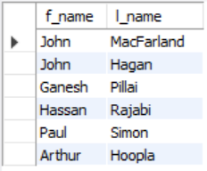

- List all employee names with salaries for employees who draw between $70000 and $90000.
Answer:
SELECT f_name, l_name, salary
FROM employee_data
WHERE salary BETWEEN 70000 AND 90000;
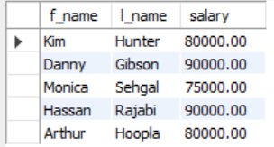
- What will the following statement display? SELECT f_name, l_name, title from employee_data
where title NOT IN ('Programmer', 'Senior Programmer', 'Multimedia Programmer');
Answer:
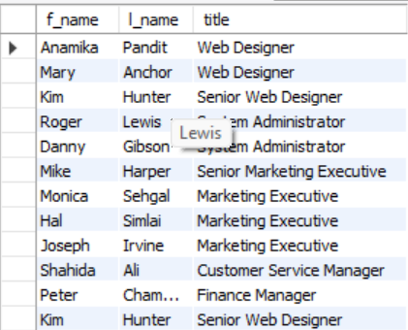
- Here is a more complex statement that combines both BETWEEN and IN. What will it display?
SELECT f_name, l_name, title, age
FROM employee_data
WHERE title NOT IN ('Programmer', 'Senior Programmer', 'Multimedia Programmer')
AND age NOT BETWEEN 28 AND 32;

Answer:
